Dotti’s first annual

lupus bike run
  - Sunday September 22nd, 2013
Events:
Live Music!
50/50 raffles!
Basket Raffles!
Door prize!
Food!
WXLO Radio Station!
Face Painting & Air Brushing!
Stuff for Sale!

Dotti Alicea is a 23 year old female suffering from Systemic Lupus, since she was Just 12. She’s undergone 10 rounds of chemotherapy but always keeps her spirits high!

Registration is at 9:00 am – 10:30 am
Please register at the Knights of Columbus (487 Worcester St, Southbridge, MA 01550) during registration you will receive a raffle ticket & a purple ribbon to either tie on your antenna or wear on your chest.

Prices: $25 dollars per driver & $5 per passenger
You may purchase tickets in advance. Cars & Jeeps are welcomed at the end of the drive.

Q: What if I don’t want to sit in the car for an hour and drive?
A: You can just meet at Brimfield Acres where there will be live music, food, 50/50 raffles and baskets! Meal Bracelets are available to purchase if you don’t ride.

Q: What if I can’t make the ride but want to donate?
A: No problem! There’s a T-Shirt that the ride can profit from to donate money. www.teespring.com/Bikerun2
Proceeds from this run will go to The Lupus Foundation of New England.

Ride route
- Left on to 169
- Left on rt 20
- Right on to rt 49 to Spencer
- Left into East Brookfield (rt9)
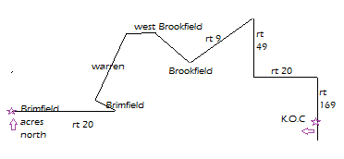
- Straight on to Brookfield
- Straight into West Brookfield
- Follow 67 into 19 in Warren
- Into Brimfield Right on rt 20 West
- End at Brimfield Acers North!

